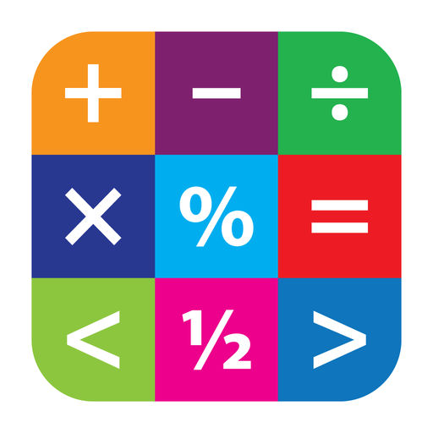
Maths
Mathematics is an important, creative and highly interconnected discipline, that helps us to understand and change the world. At Shield Row Primary School, we want all pupils to experience the beauty, power and enjoyment of this subject, whilst developing their natural curiosity and enhancing their resilience, so they become ‘deep thinkers’. We foster positive attitudes to learning as we believe all children can achieve in mathematics. Engaging lessons teach for secure and deep understanding of mathematical concepts through manageable steps. We use mistakes and misconceptions as an essential part of learning and provide challenge through rich and sophisticated problems. At our school, we aim for pupils to become true masters of their year group content, applying and being creative with new knowledge in multiple ways. We intend for all pupils to:
- Become fluent in the fundamentals of mathematics so that they develop conceptual understanding and the ability to recall and apply knowledge rapidly and accurately;
- Be able to solve problems by applying their mathematics to a variety of problems with increasing sophistication, including in unfamiliar contexts and to model real-life scenarios;
- Reason mathematically by following a line of enquiry and develop and present a justification, argument or proof using mathematical language;
- Have an appreciation of number and number operations, which enables mental calculations and written procedures to be performed efficiently, fluently and accurately to be successful in mathematics.

 | Year 1 | Year 2/3 | Year 3/4 | Year 5 | Year 6
Autumn | Place Value (to 20)  Addition & Subtraction  Geometry: 2d and 3d Shape  Measures: Time Sequencing  Problem Solving: Trial & Improvement; Finding all Possibilities | Place Value (100/1,000)  Addition & Subtraction (including Money)  Multiplication  Problem Solving: Trial & Improvement; Finding all Possibilities | Place Value (1,000/10,000)  Addition & Subtraction  Multiplication & Division (tables facts)  Problem Solving: Trial & Improvement; Finding all Possibilities | Place Value (to 1,000,000)  Addition & Subtraction  Statistics  Multiplication & Division  Measures: Perimeter & Area  Problem Solving: Trial & Improvement; Finding all Possibilities | Place value (to 10,000,000)  Addition & Subtraction  Multiplication & Division  Fractions  Decimals  Problem Solving: Trial & Improvement; Finding all Possibilities
Spring | Place Value (to 50)  Multiplication & Division  Fractions  Length & Height  Weight  Volume & Capacity  Problem Solving: Number Patterns & Working Backwards | Division  Statistics  Measures: Length & Height  Geometry: Shape; Position & Direction/Perimeter  Fractions | Multiplication & Division (formal)  Measures: Length, Perimeter & Area  Fractions  Y3 Measures: Mass & Capacity/  Y4 Number: Decimals  Problem Solving: Number Patterns & Working Backwards | Multiplication & Division: Formal Methods  Fractions  Decimals & Percentages  Problem Solving: Number Patterns & Working Backwards | Percentages  Consolidation: Fractions, Decimals & Percentages  Statistics  Measures: Perimeter, Area & Volume  Measures: Converting Units  Geometry: Position & Direction
Summer | Place Value (within 100)  Measures: Money  Measures: Time  Geometry: Position & Direction  Consolidation  Investigations  Problem Solving: Visualising; Conjecturing & Verifying | Measures: Time  Problem Solving & Efficient Methods  Problem Solving: Number Patterns & Working Backwards  Measures: Mass, Capacity & Temperature  Consolidation & Investigations  Problem Solving: Visualising; Conjecturing & Generalising | Decimals (including Money)  Measures: Time  Statistics  Geometry: Properties of Shape; Position & Direction  Problem Solving: Visualising; Conjecturing & Generalising | Decimals: Add & Subtract; Multiply & Divide by 10, 100, 1,000  Geometry: Properties of Shape  Geometry: Position & Direction  Measures: Converting Units  Measures: Volume  Problem Solving: Visualising; Conjecturing & Generalising | Algebra  Ratio  Geometry: Properties of Shape  Problem Solving: Number Patterns & Working Backwards  Investigations  Problem Solving: Visualising; Conjecturing & Generalising

