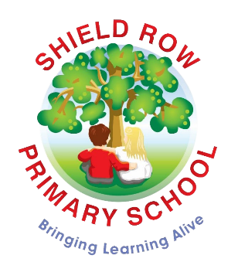

Shield Row Primary School

Application for a Nursery Place

Child’s Name:
Address:

Telephone Number:

Email:

Child’s Date of Birth:
Name of Parent/Carer:
Name of any children and/or relations already attending Shield Row School:

Nursery Hours Required (15 or 30):
Is your child currently attending another nursery? | Yes  Name of Nursery: | No
If your child has a Statement of Special Educational Needs or will require additional support in Nursery, please inform us as soon as possible.
Date of Application:

Signed:

To be completed by the school:

Date of Child's entry into Early Years Provision

